**Note: I have submitted the same file for both linux and git by mistake, so I’ll add the git exercises at the end of linux ones, sorry for this.**

1. **Mkdir -p exercise/dir1/dir2/dir3**

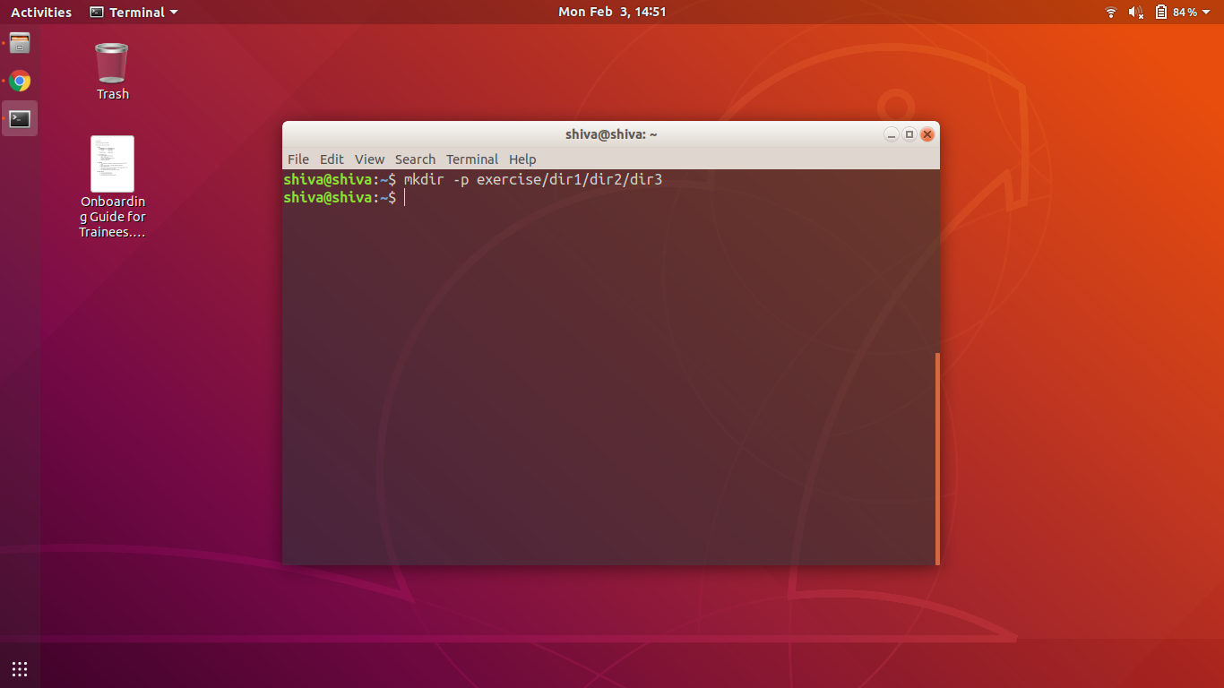

2)touch emptyFile1 emptyFile2

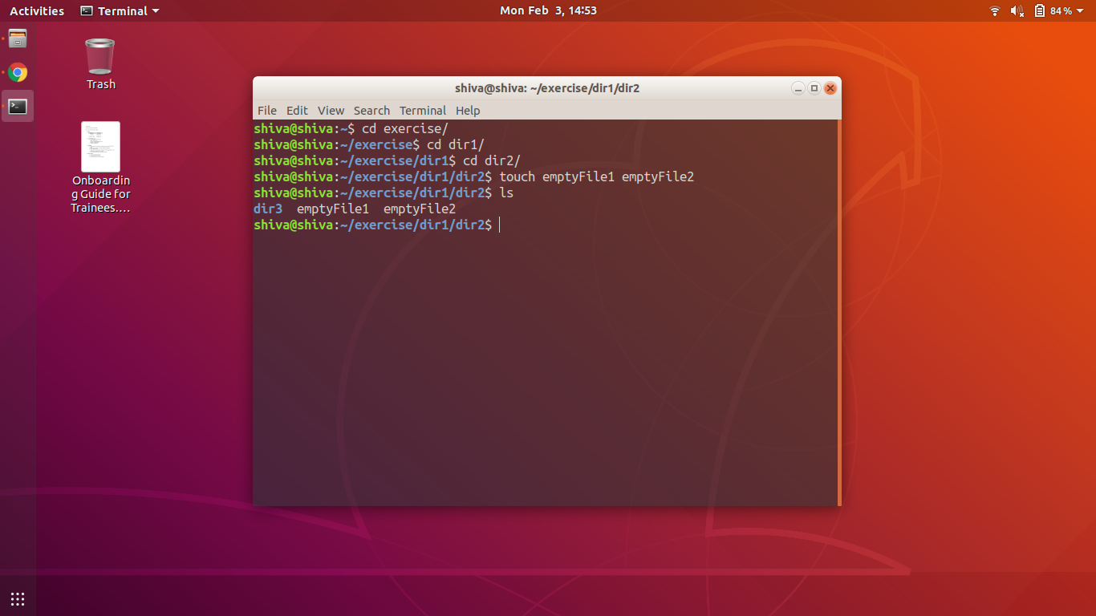

3)cat > file1.txt

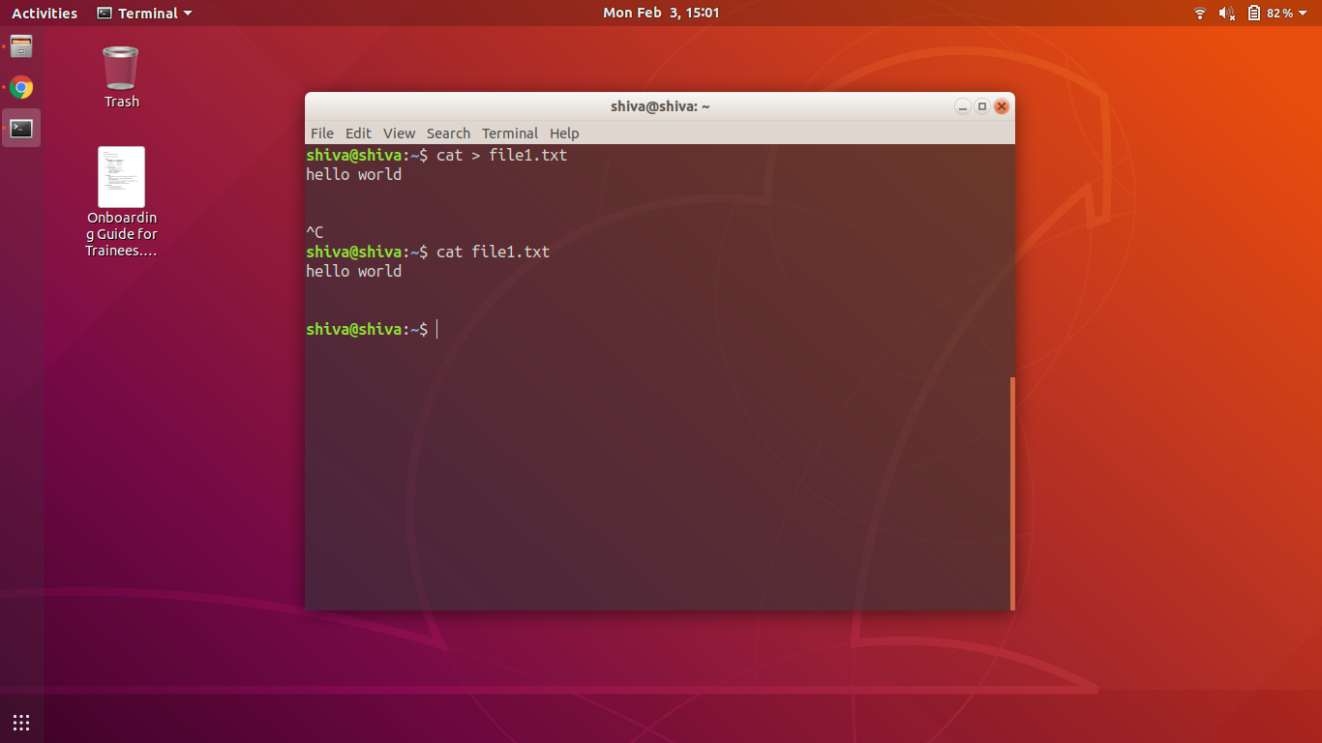

4)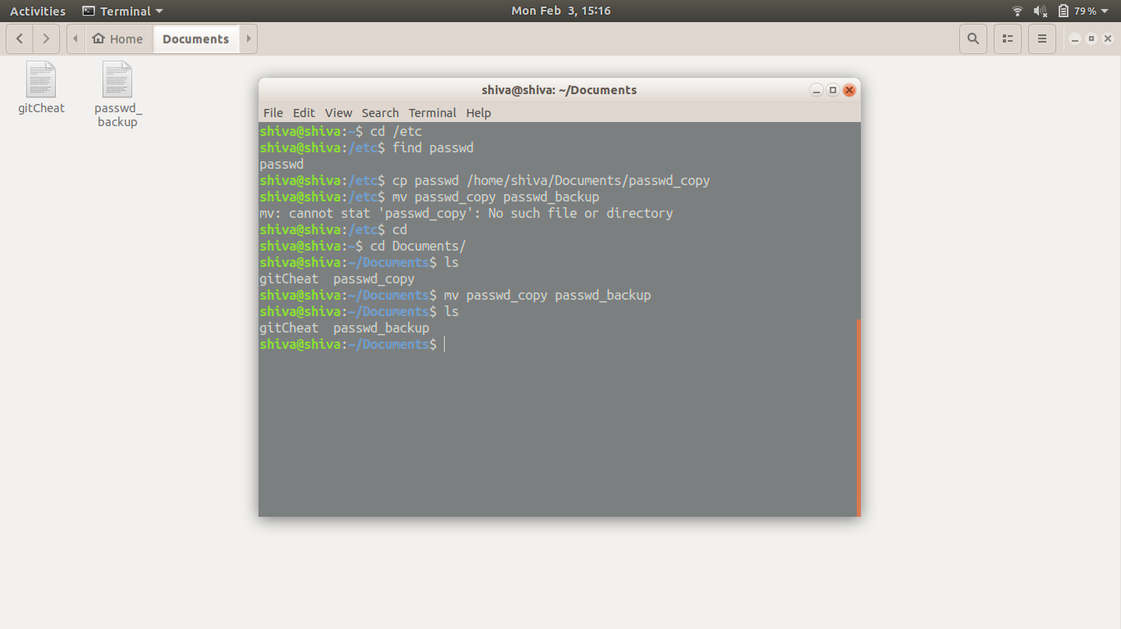

5)(i)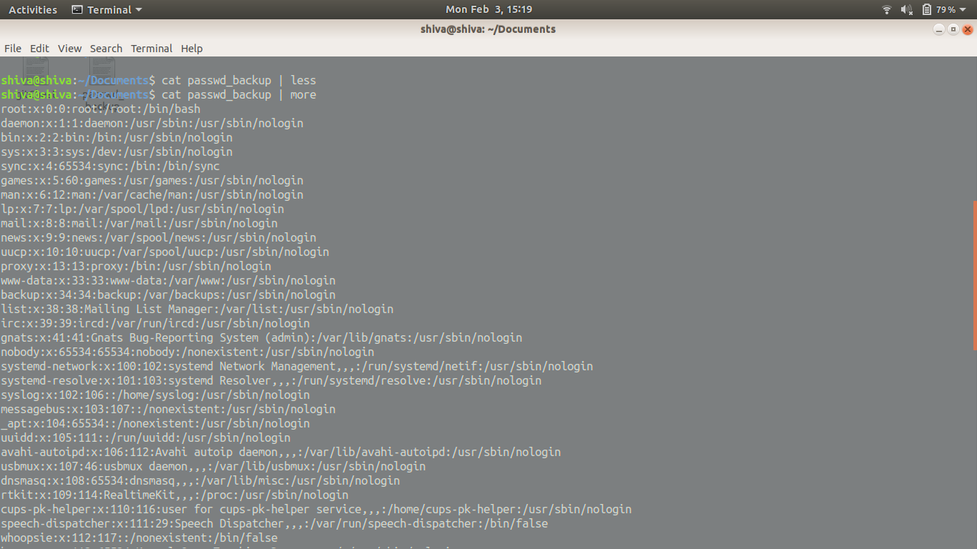

5)(ii)

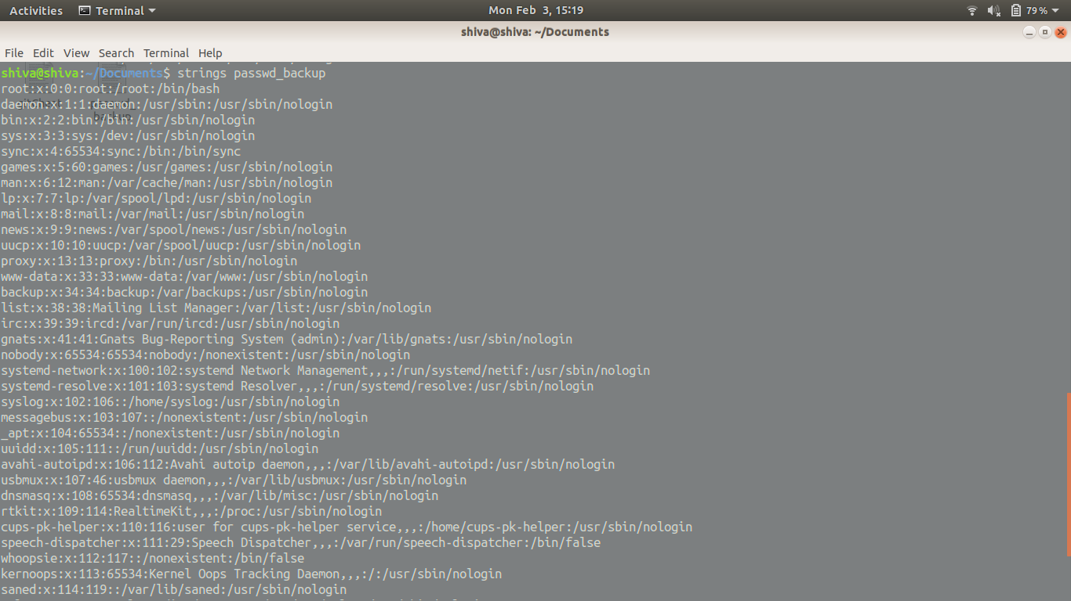

**Answer of 5 ->**  The main differences are:

* Less is used to display the content and have a line by line scrolling view which fits in according to the page orientation
* More is similar to less but does not allow to toggle each line to go back
* Strings just displays all the content of the file in one go.

6)**grep -w -c /bin/false passwd_backup**

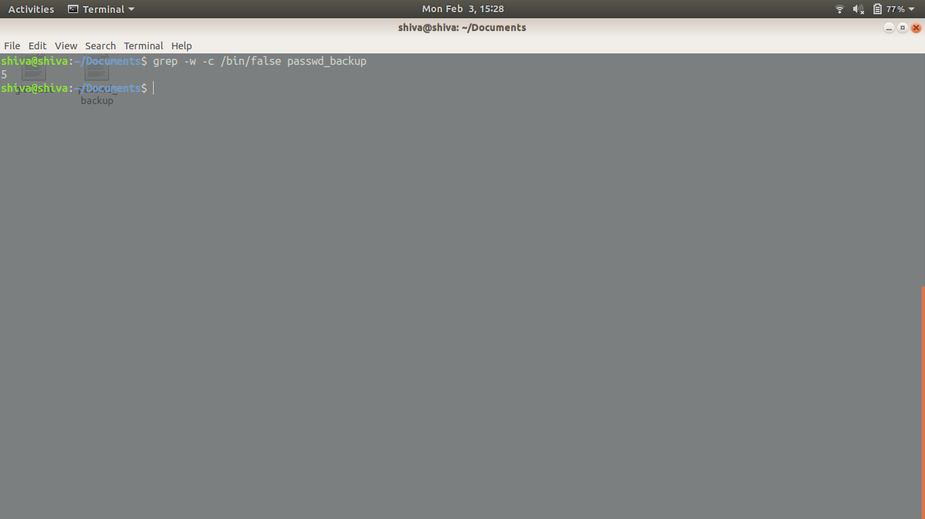

7)**head -5 passwd_backup > output.txt**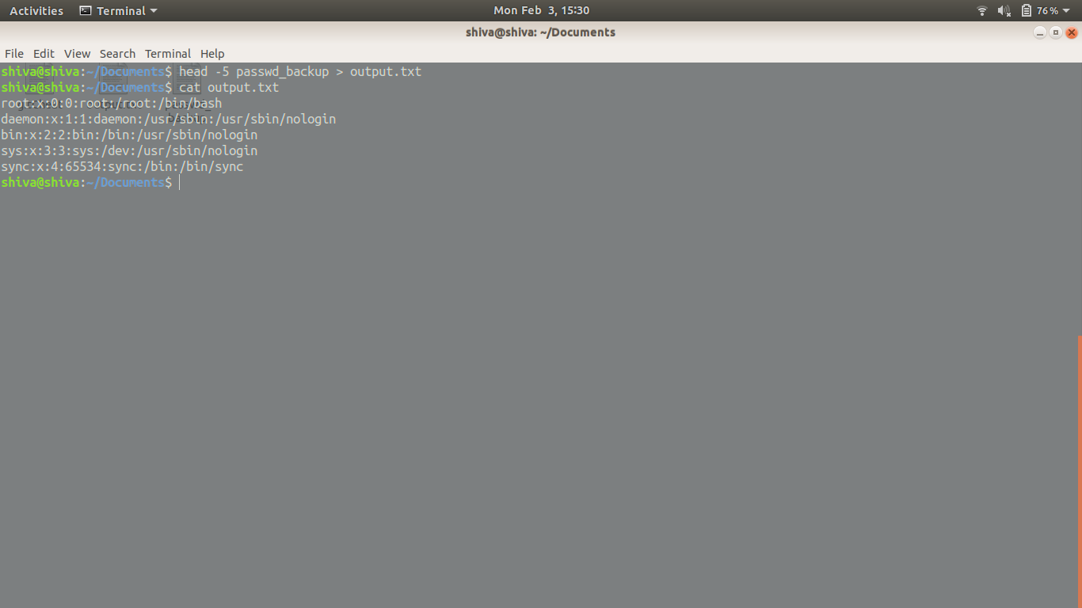

8) **sudo adduser** after that **id**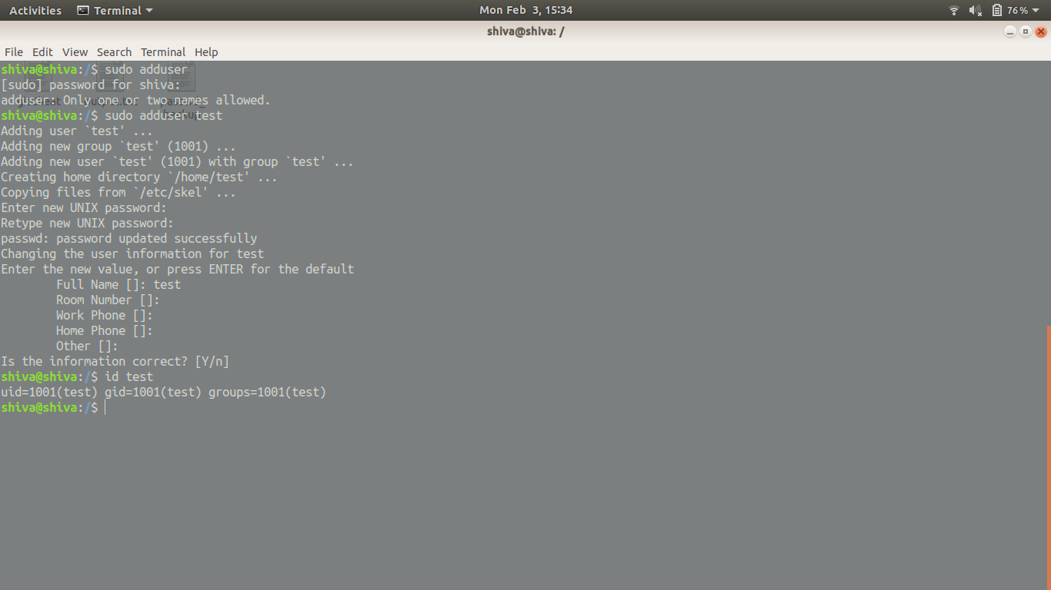

9)**touch emptyFile1 emptyFile2**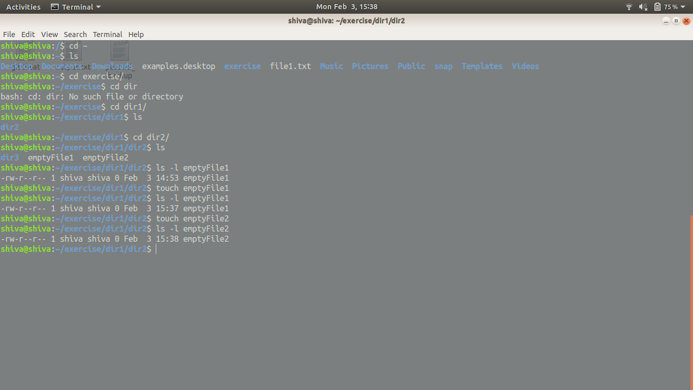

10)sudo adduser test shiva , chmod 777 output.txt(dangerous but works)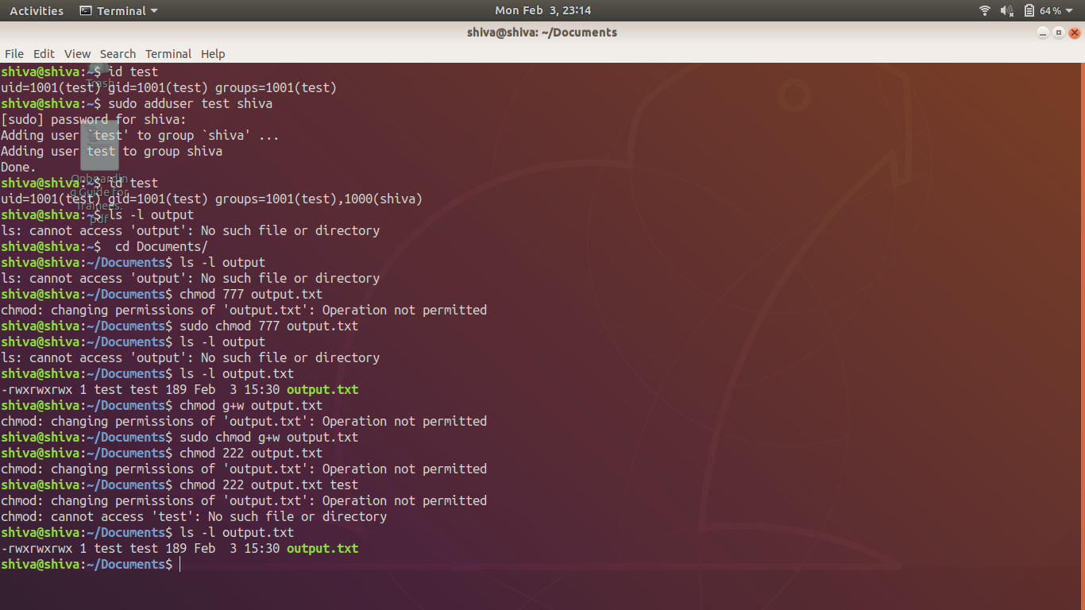

11)**alias shiva=”touch tmp/alastsring”**

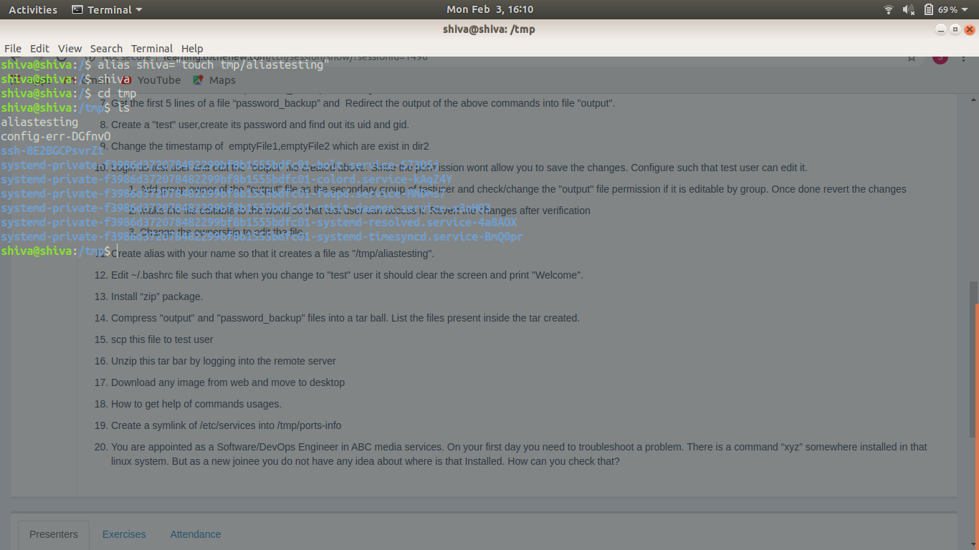

13)**sudo apt-install zip**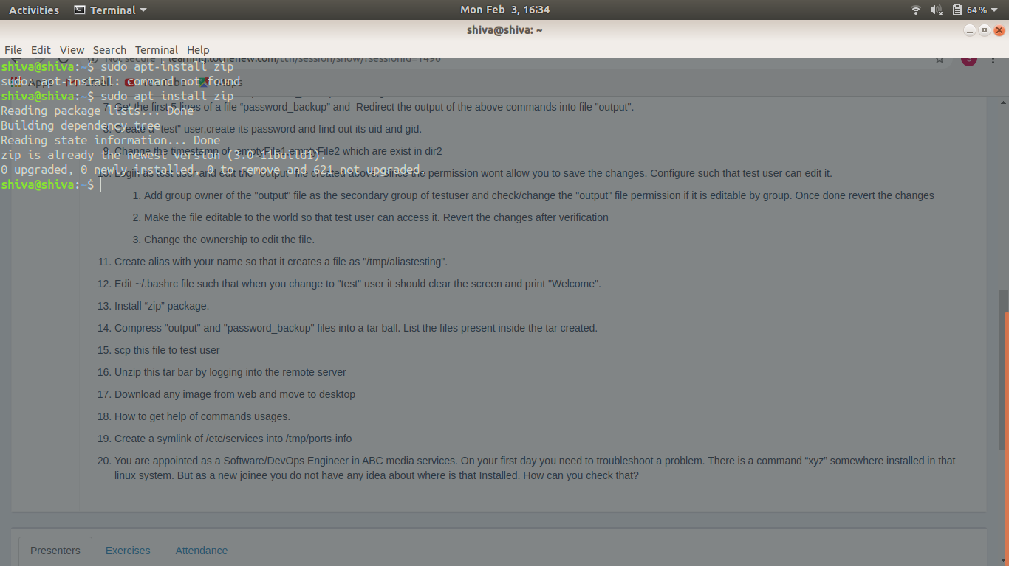

14)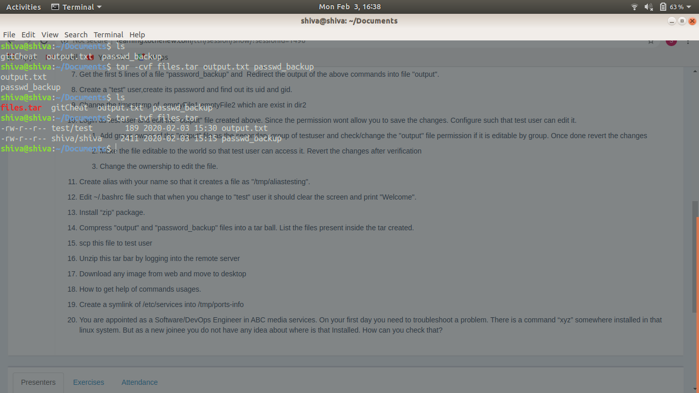

15)**scp files.tar test@localhost:/home/test**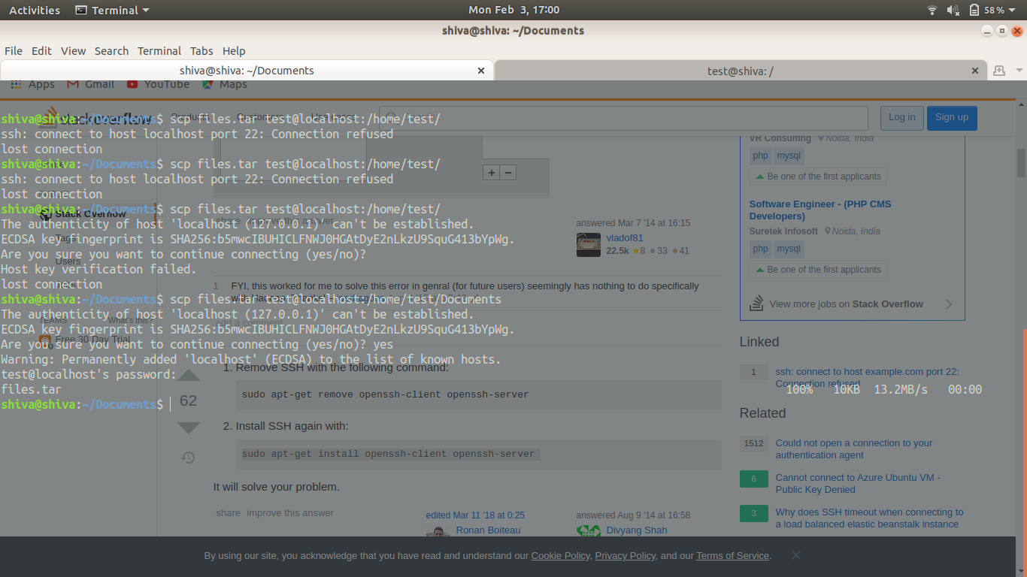

16)**sudo cat /home/shiva/Documents/files.tar | ssh shiva@localhost "tar xf - -C /home/shiva/Downloads"**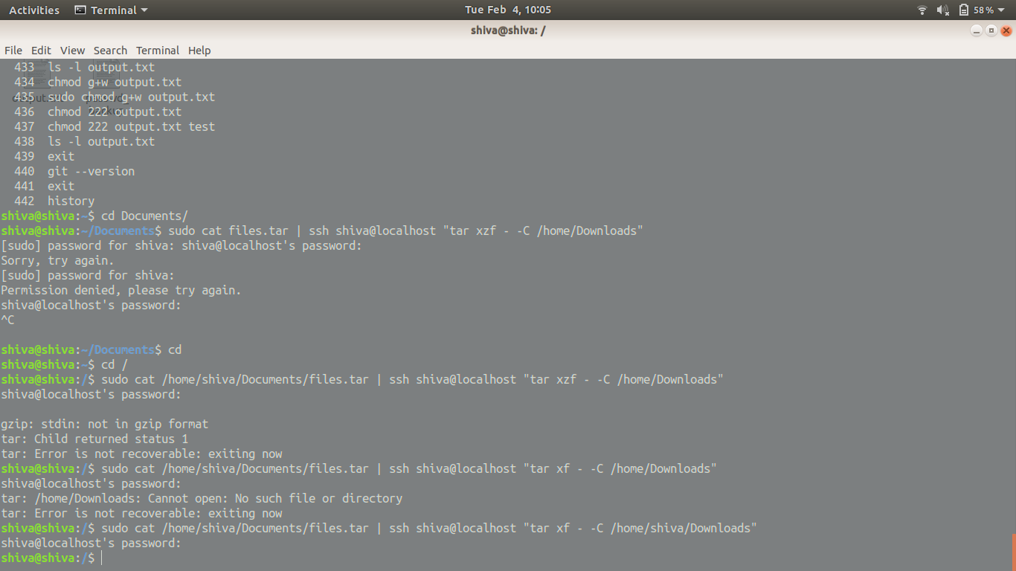

17)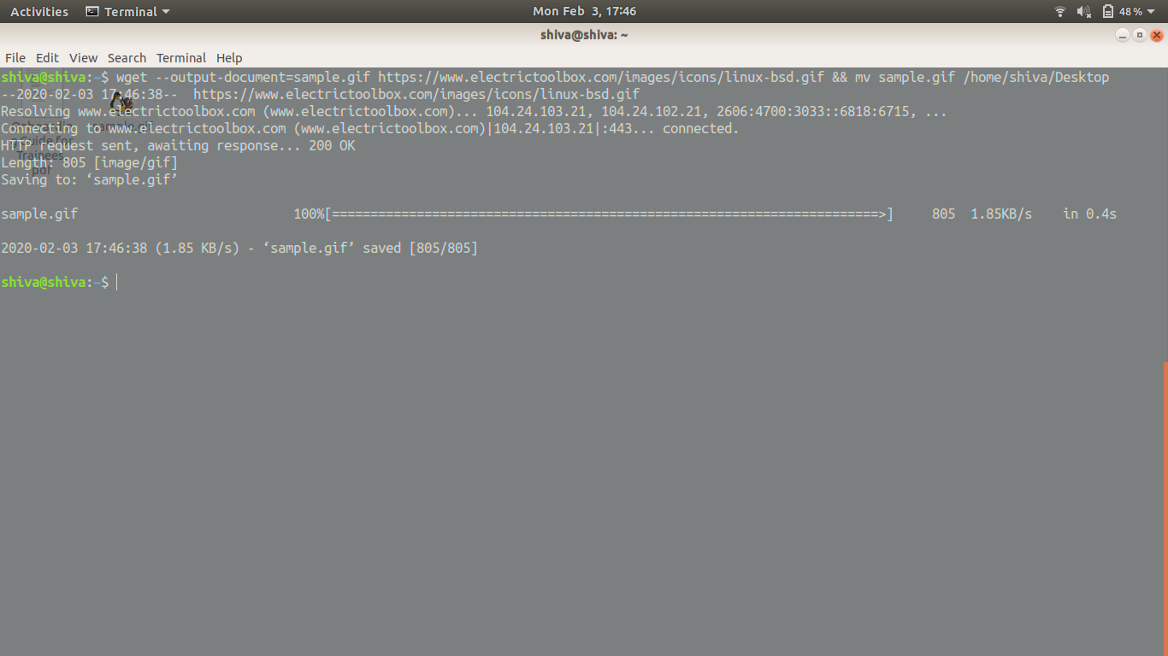

18) man command can be used for details and --help can also be used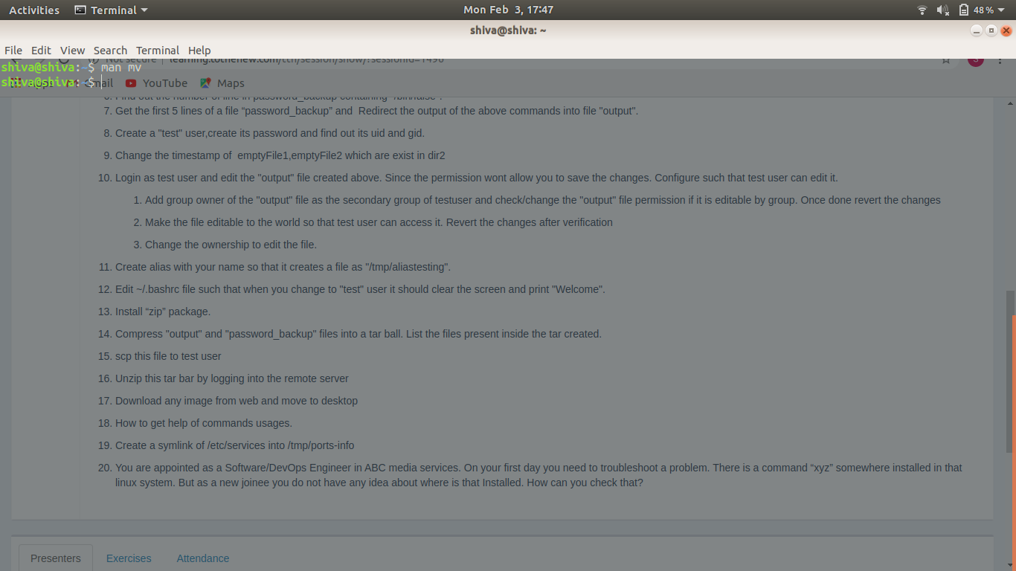

19)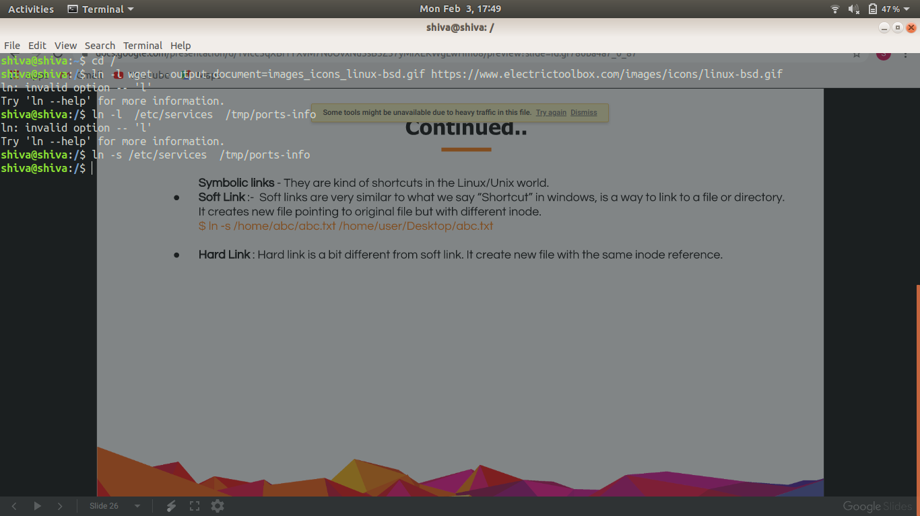

20)

Which command should I use?

Ans - It really depends on the what I want to do:

* If I want to find a linux program then I will use **whereis**
* If I want to find executable then I will use **which**
* For quick but not too accurate search I’ll use **locate**
* For searching a personally created file I’ll use **find**

**DAY2 GIT (VCS)**

1. **Set up git - done on laptop -**

**git config --global user.name "Your Name”**

**git config --global user.email "youremail@domain.com"**

1. **Git init**

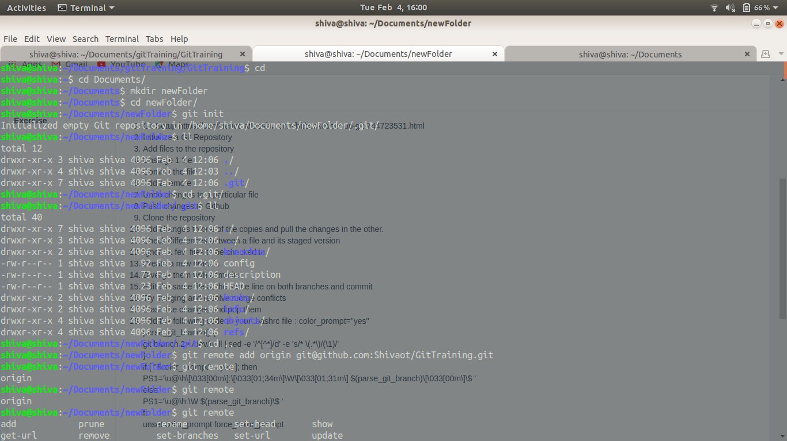

**3)git add .**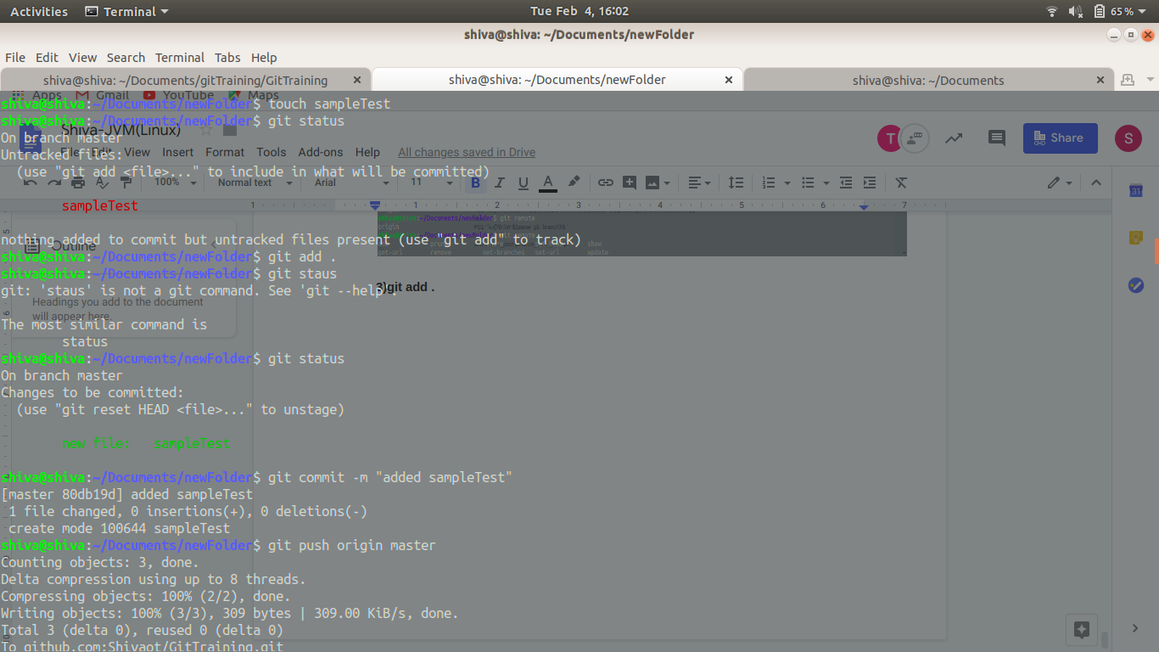

**4) git reset filename**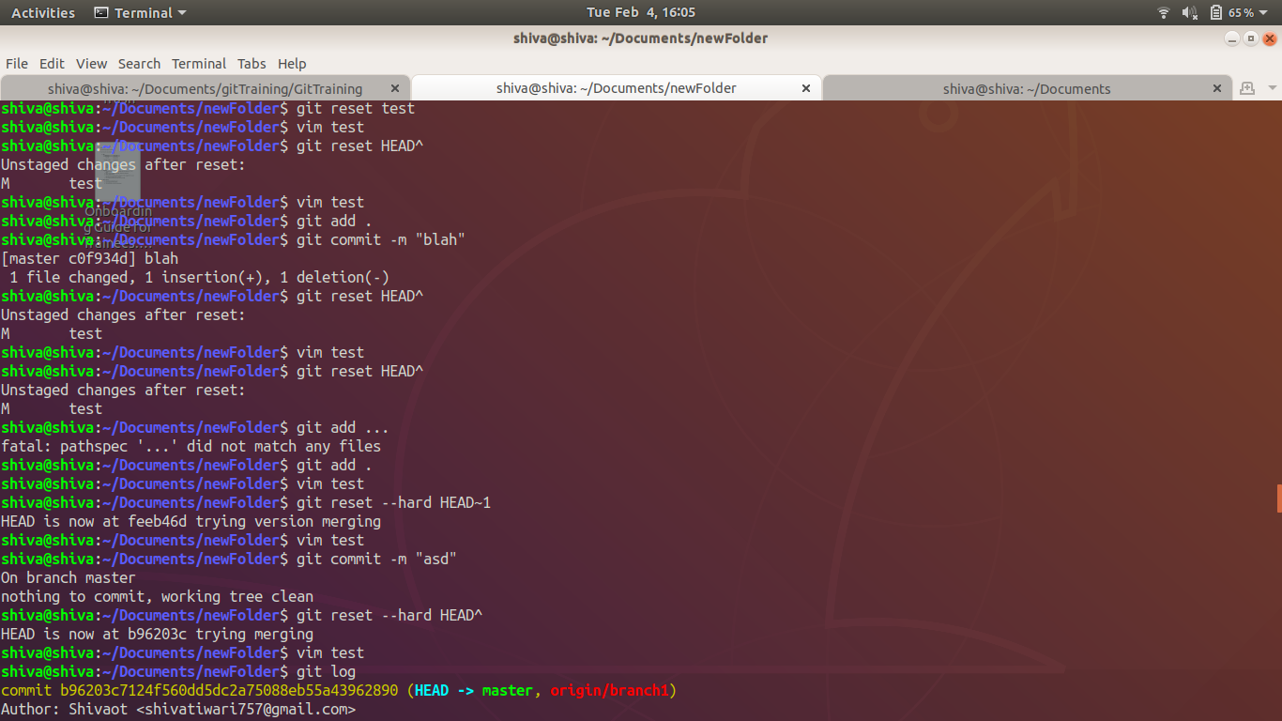

**5) git commit -m “commit message”**

**6)git remote add origin git@github.com:Shivaot/GitTraining.git**



**7)git reset --hard HEAD~1**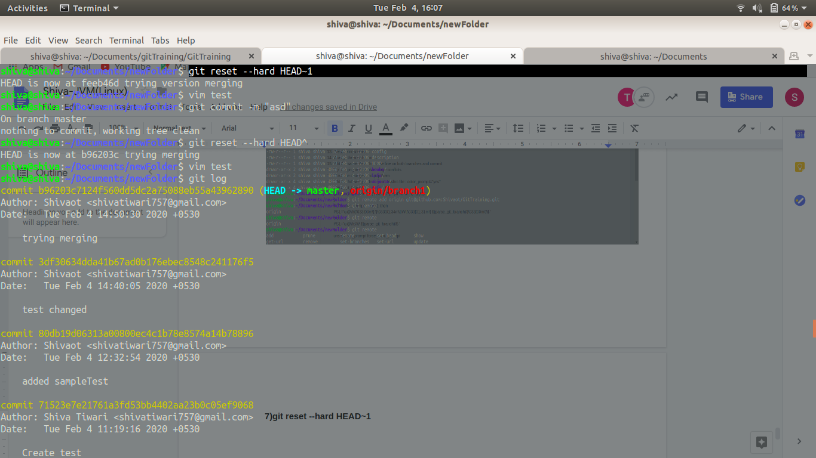

**8)git push origin master(branch name)**



**9) git clone <sshurl>**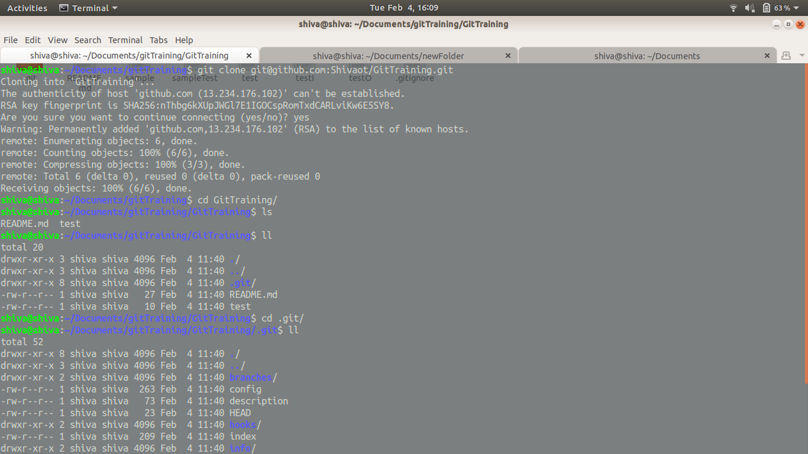

**10)git add .**

**Git commit -m “msg”**

**Git checkout branchname**

**Git merge prevBranchName**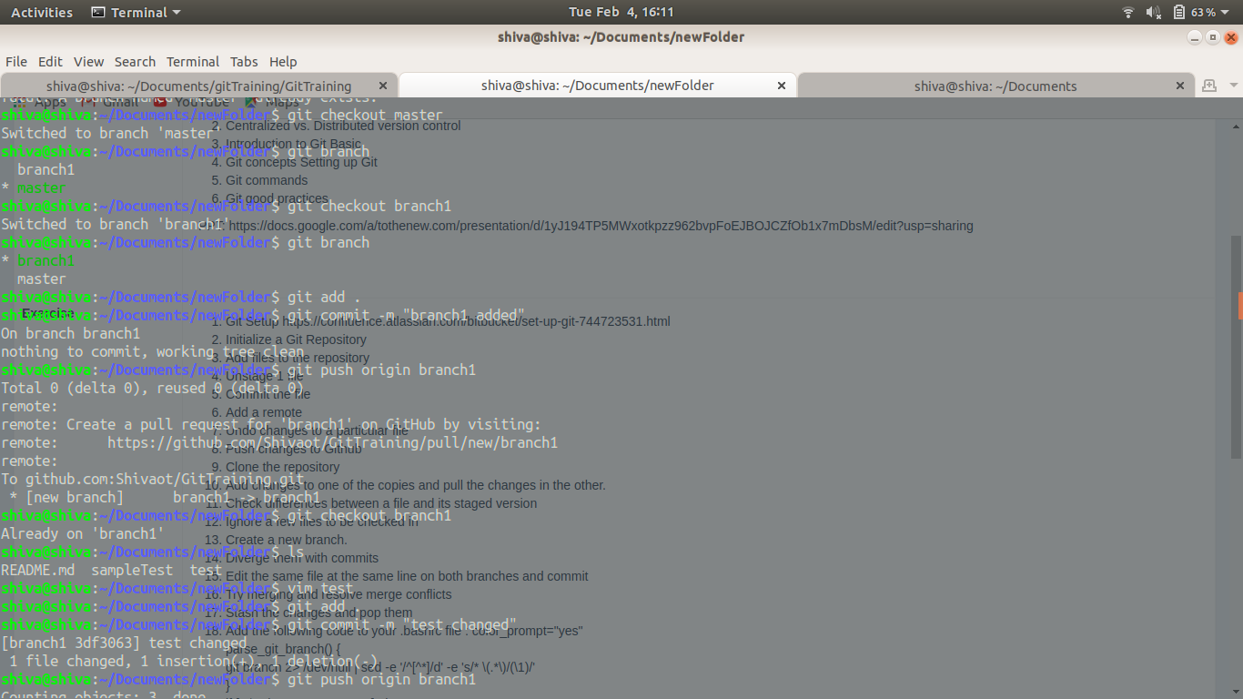

**11)git diff --cached**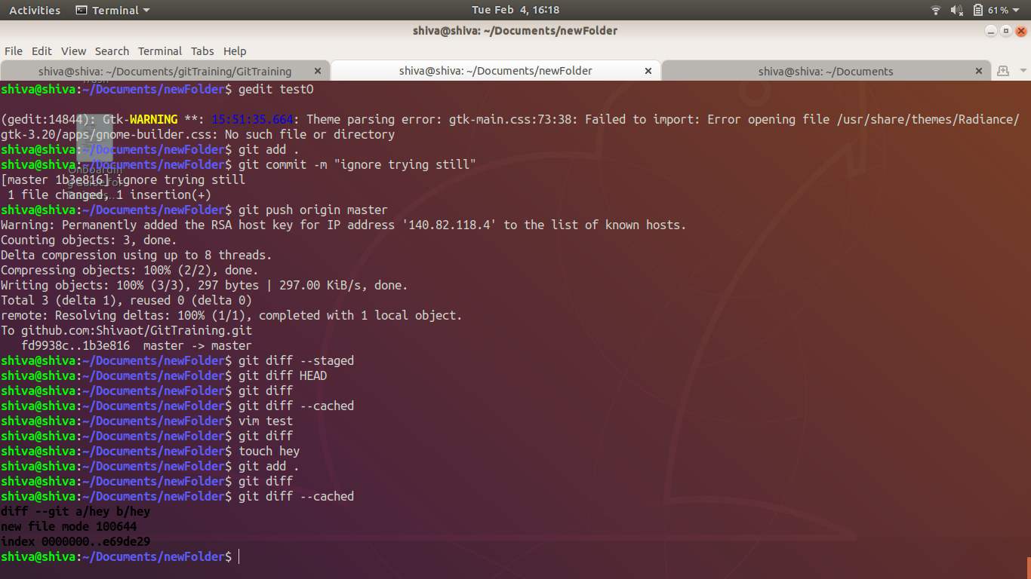

**12).gitignore** 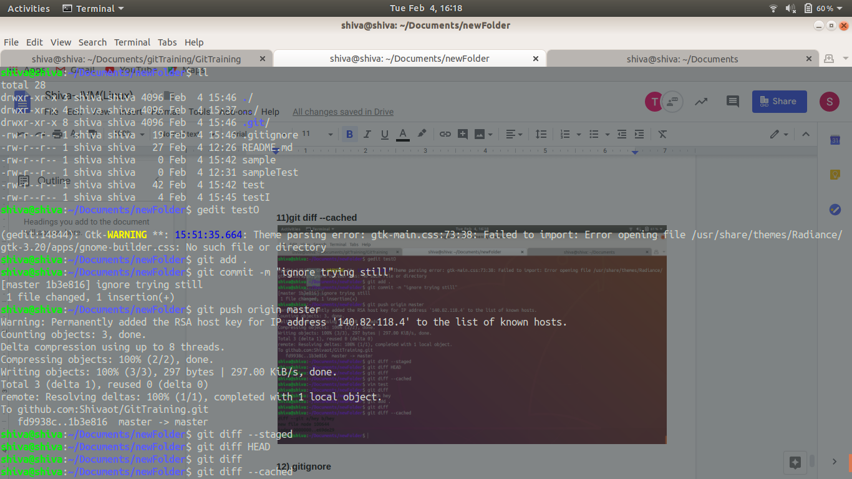

**13)git checkout -b branch1**

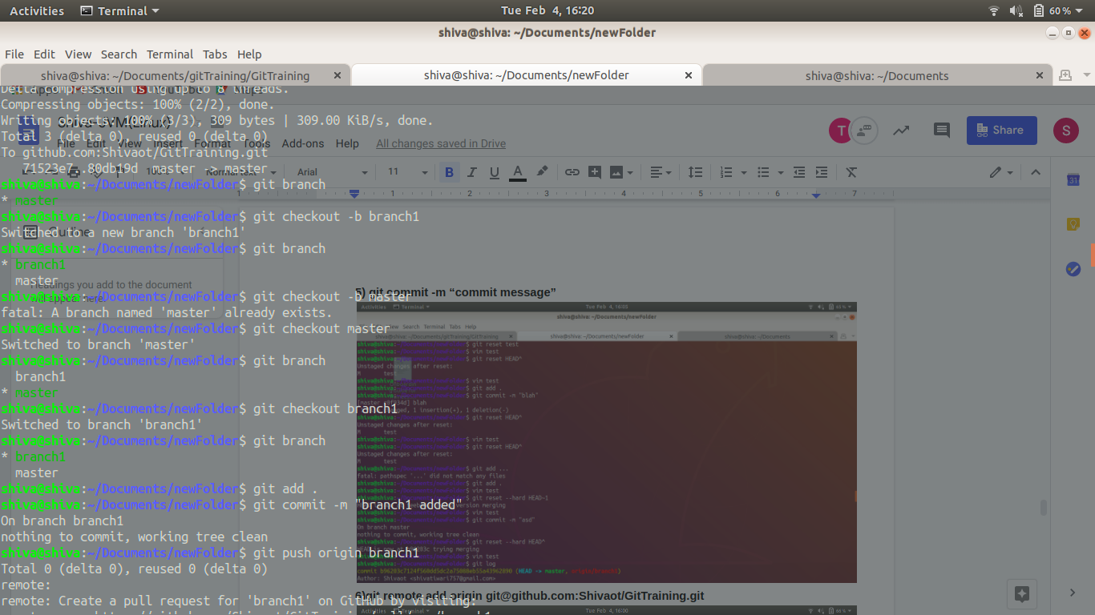

**14) steps -**

**Git checkout branch1**

**Change file**

**Git add .**

**Git commit -m “msg”**

**Git checkout master**

**Change file**

**Git add .**

**Conflict comes**

**Select the one which want to continue with**

**Git add .**

**Git commit -m “msg”**

(same thing is done on screenshots)

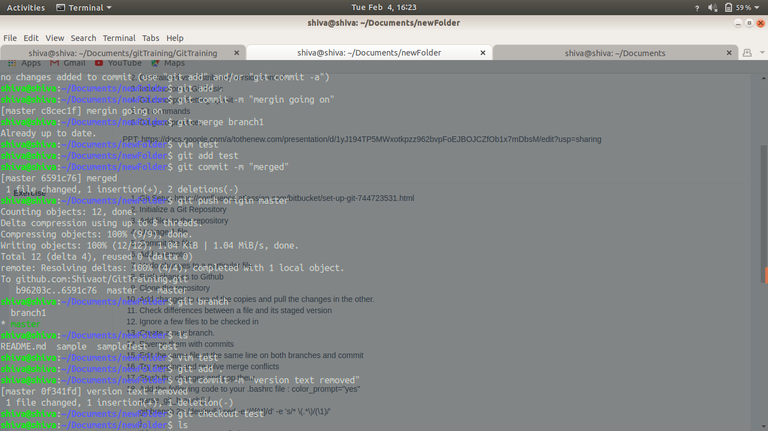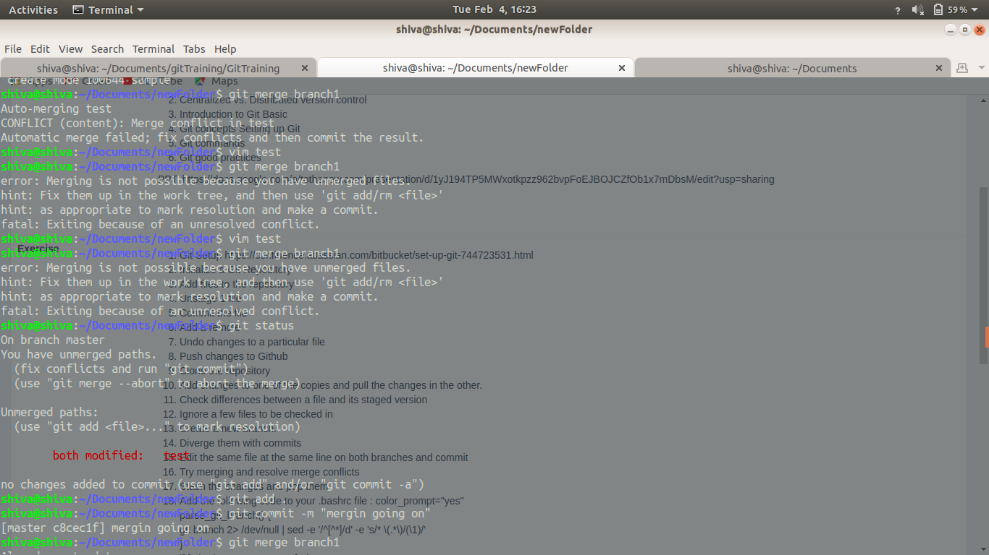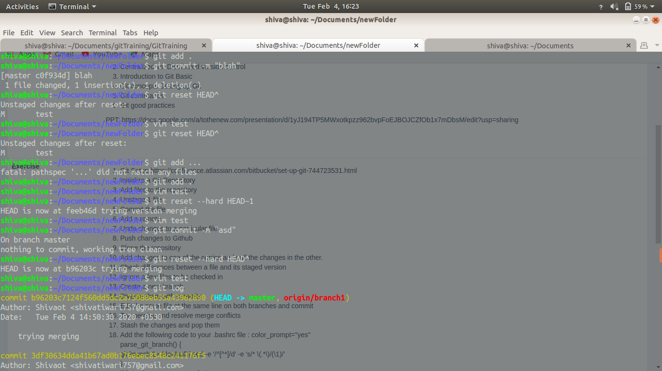

**15)** 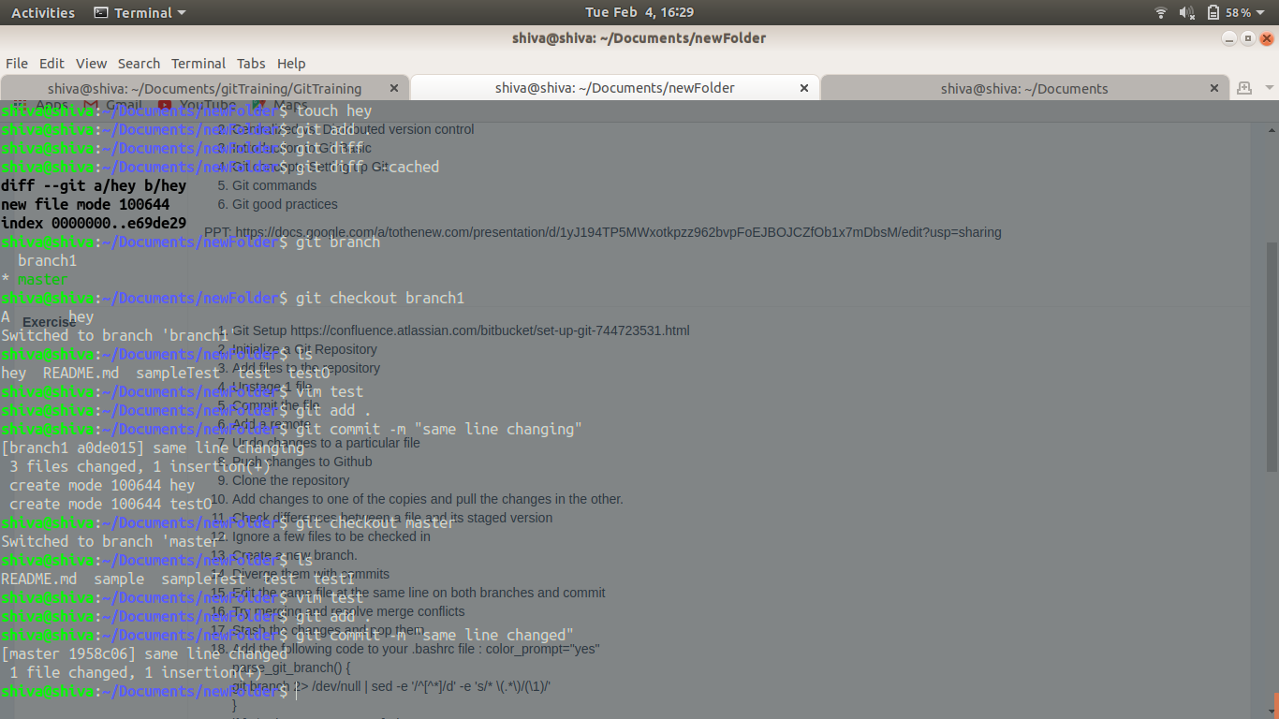

**16)Git checkout branch1**

**Change file**

**Git add .**

**Git commit -m “msg”**

**Git checkout master**

**Change file**

**Git add .**

**Conflict comes**

**Select the one which want to continue with**

**Git add .**

**Git commit -m “msg”**







**17)git stash**

**git stash pop**

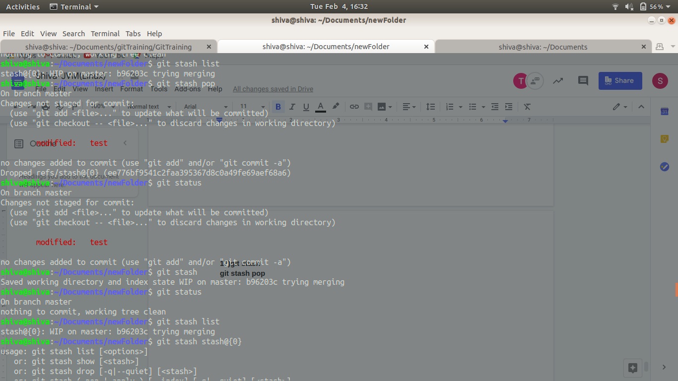

**18)**

